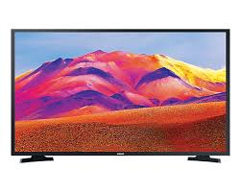
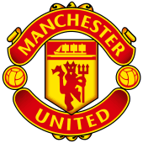
Grand Draw
Raffle Prizes!!!
Top 3 Prizes
- 2 x American Football Tickets & Meal at Fire Restaurant Dublin
- Bella Rosa Cottage Hamper & Half Day SPA Voucher
- 2 x Manchester United Tickets

Many More great prizes……………………….
- 1 year sports massage Voucher from Garreth Thornton
- Inveja Hair Voucher
- 32” Walker TV - Newage Electrical
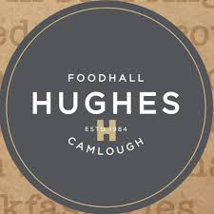
- £250 Voucher from Andrew Mackin Photography
- 2 x Premium Pass for Titanic Distillery
- £100 Voucher for Foodhall Hughes’ Camlough
- Lady’s Zurich Watch
- Men’s Zurich Watch
- Girl’s Bicycle – Ring of Gullion Cycles
- Lady’s watch from Bennett’s Jewellers
- £70 Voucher from Bow’s Boutique
- £50 Voucher from Bogart
- £40 Voucher from Roisin Gallogly Hair
- £30 Gents Hair from Canning Cuts
- £25 Voucher for any treatment at Airmid Therapies and a candle
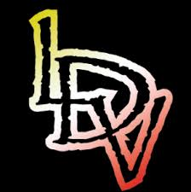
- £25 Voucher from La Dolce Vita
- £25 Voucher from La Dolce Vita
- Meat Parcel from Taste of Gullion
- Tropic Hamper – Donna Kirk
- Large Fruit Basket from Phillips Fruit
- Red wine gift set

