Prospectus

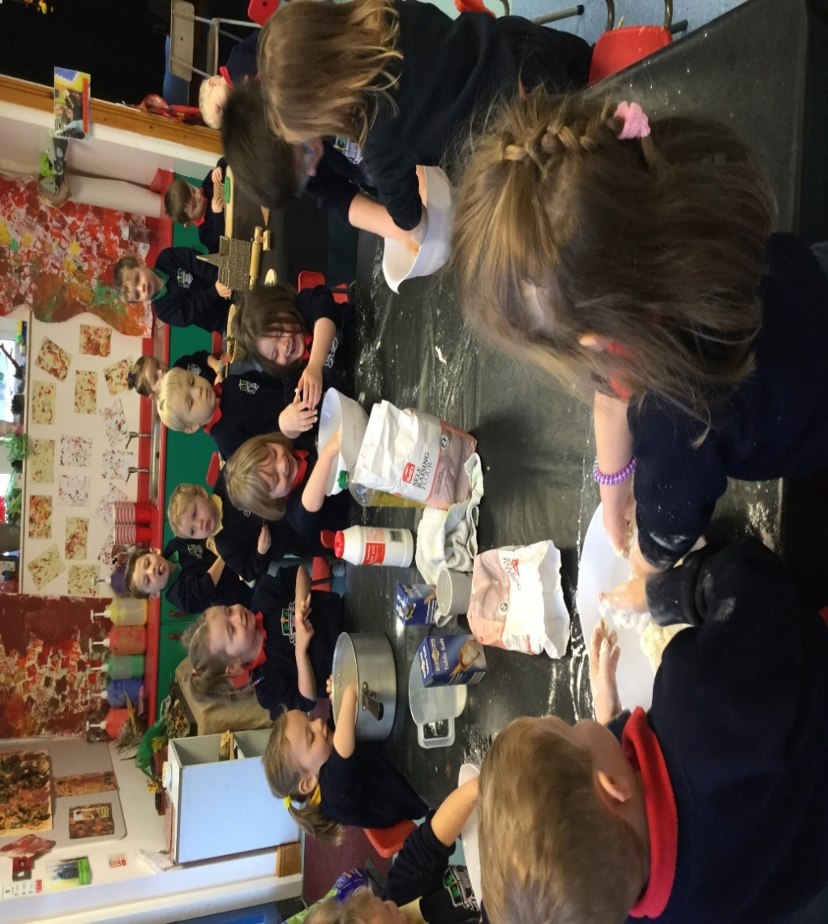

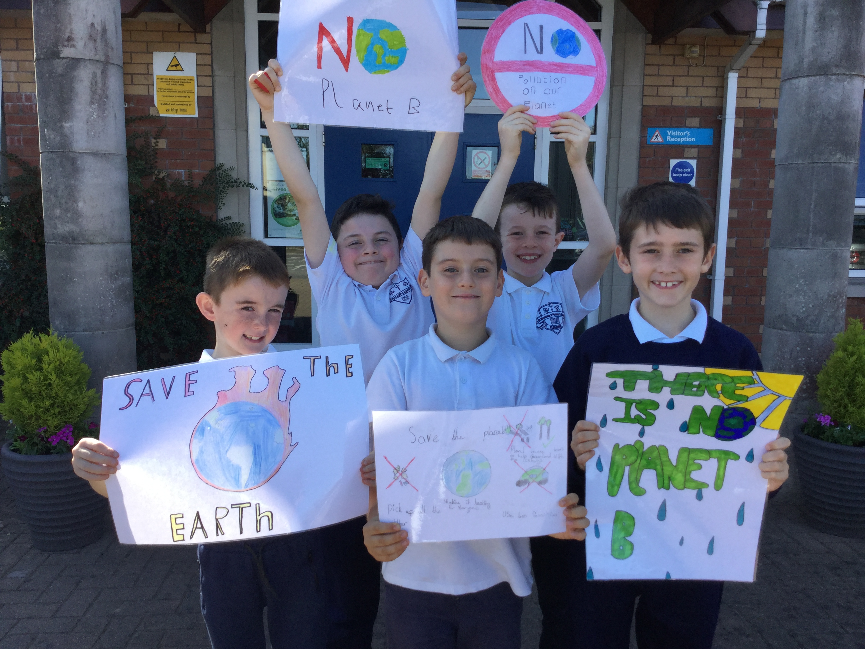

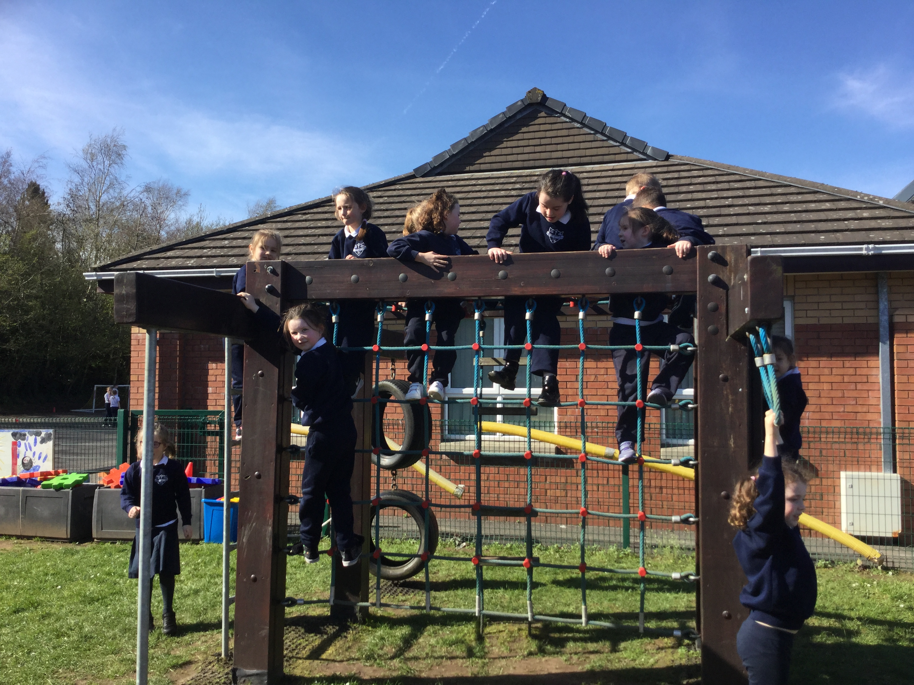

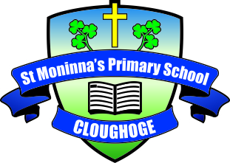

St. Moninna’s
Nursery
And
Primary School

Introduction

Chair of Governors: Mr John Doherty St.Moninna’s P.S. Cloughoge
Principal: Mrs Isobel Temple 81 Chancellor’s Road
Newry
BT35 8NG
Telephone: 02830262688
Fax: 02830267730
info@cloughoge.newry.ni.sch.uk
www.cloughogeprimaryschool.com

Dear Parent/Guardian,

Welcome to St. Moninna’s Primary School and Nursery Unit. I am delighted that you are considering sending your child to our school.

St. Moninna’s Primary School is a Catholic Maintained Co-educational Primary School catering for pupils from age 3 to 11. There are currently 470 pupils enrolled in the school. There are two nursery classes in a purpose built nursery and two of each class from Primary 1 to Primary 7 and all of our classes are mixed ability.

I hope this prospectus will give you an introduction to our school. However, if you wish to discuss anything further or view the school premises, do not hesitate to contact us. I look forward to meeting you and your child and hope it will be the beginning of many happy years of working together.

Yours Sincerely,

Isobel Temple
Principal

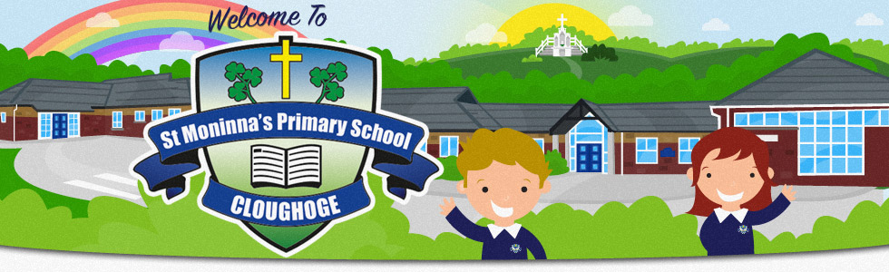

Application and Admission

A copy of the Primary School’s Admissions Criteria and the Admissions Criteria for the Nursery is published by the Education Authority and is available on their website www.eani.org.uk. Prospective parents are most welcome to visit the school. If they wish to do so they should contact the school office to make an appointment with the principal.

Year | Nursery  Applications | Nursery  Admissions | Primary1 Applications | Primary 1  Admissions
2017/18 | 72 | 53 | 65 | 61
2019/19  2019/20  2020/21 | 61  64  52 | 53  53  52 | 67  63  60 | 60  60  60

Nursery
All prospective parents/guardians of the Nursery School children will be invited to individual meetings in the Nursery during June. Parents/guardians will have the opportunity to meet their child’s teacher and assistant and view the nursery building. Literature will be distributed giving details of the actual dates for enrolment for each child. Welcome booklets are provided to share with your child. Children do not attend this meeting. However, parents/guardians will be invited to bring their children to the Nursery for an open session. You will also have the opportunity to meet the school principal at this open session.

Entrants to P1
The vast majority of entrants to P1 will be those who have already spent a period in St. Moninna’s Nursery, Cloughoge. A series of transition sessions are provided to help the pupils become familiar with their new placement. New parents/guardians and their children will have an opportunity to spend ‘a getting to know you’ session with their teacher in P1 and meet the Principal who will inform them of the September arrangements for starting school. They will also be provided with a welcome booklet to share at home. This usually takes place in late June. An information session for all parents/guardians will be held in September.

New Parents/Guardians P2 – P7
You will be invited to meet the Principal and be given an opportunity to view the school premises. You may also have the opportunity to meet your child’s prospective teacher.

Mission Statement

St. Moninna’s, Cloughoge (Primary and Nursery Unit) is a Catholic school living with Christ at its heart. It is with this foundation that all adults, by example, aim to celebrate the uniqueness of every child and value all their contributions. We will ensure our children are happy, healthy, secure, respected and cared for in their learning environment.

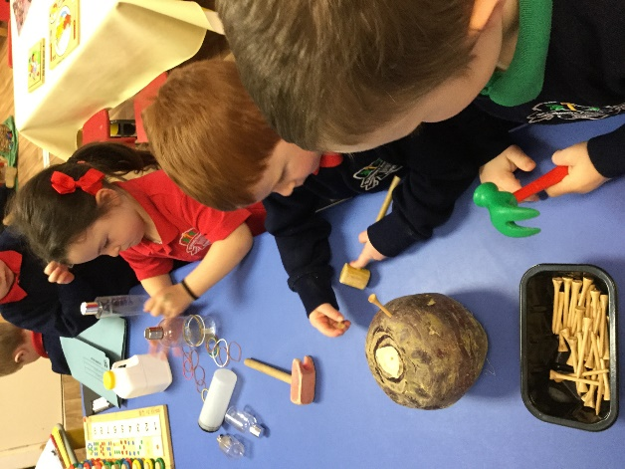

Aims
St. Moninna’s P.S., Cloughoge in partnership with our parents and guardians aims to:

- Share and promote our Catholic ideals, values, and beliefs so our whole community has mutual respect.

- Promote the spiritual, personal, social, health and academic goals desirable for all our pupils in order to mould them into caring and responsible citizens of the future.

- Enable our children to become articulate, literate and numerate with early intervention in place as required.

- Ensure all may become independent and confident learners in a well-resourced environment.

- Encourage the children to develop lively, enquiring, imaginative and creative minds with the ability to question and argue rationally.

- Highlight the dignity and worth of each individual and promote the development of the whole person to be the best each can be, as valuable contributors to running our school effectively.

- Promote the multicultural nature of society and to foster respect for those with different religions, beliefs and ways of life.

- Involve parents, local schools and the local community as active participants and mutual partners in the education of our children.

- Ensure we deliver the Northern Ireland Curriculum to the highest standard and include a broad range of rich and meaningful experiences as part of the children’s development in school time or as extra-curricular activities.

- Foster children's awareness of, and a caring attitude towards, their local and wider community and environment, and of the effects their actions can have on them.

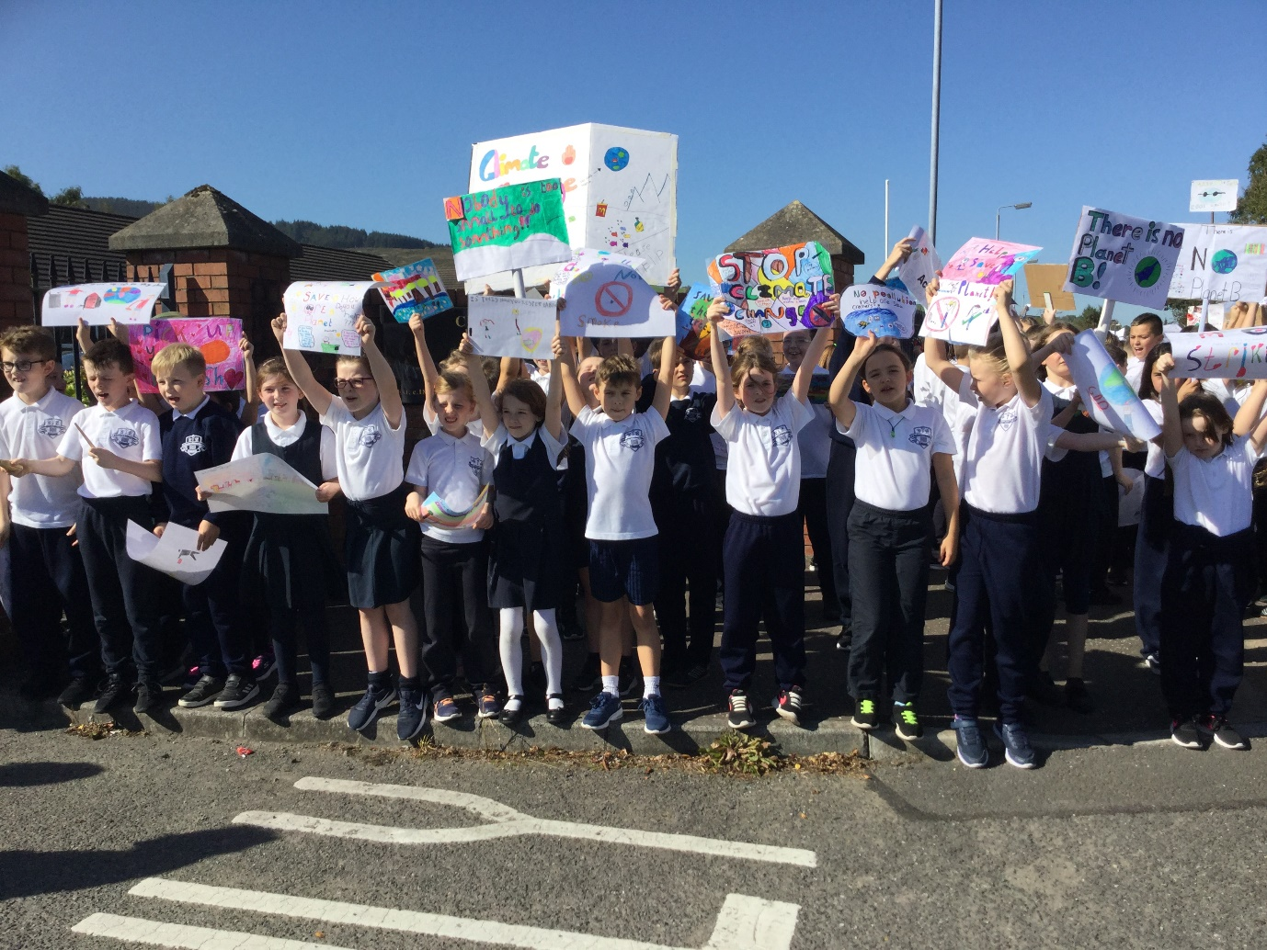

Curriculum
It is the policy of the Board of Governors of St. Moninna’s P.S., Cloughoge that all the pupils will receive their full entitlement under the Northern Ireland Curriculum. The School Development Plan is continually updated to take cognisance of changing needs, DENI policy and other initiatives. It is the tool for self-improvement for the whole school community where everyone has a say with an emphasis on promoting Literacy and Numeracy.
The curriculum shall be implemented so that the desire to learn will be encouraged in the pupils and that thinking and reasoning will be stimulated. It is important that children learn to independently apply themselves to the work in hand and are ready for transition at every stage.
The acquisition of knowledge and skills and understanding of what has been learned will be regarded as very important. This acquisition will, however, be placed in the context of the development of sound moral values based on the Catholic faith.

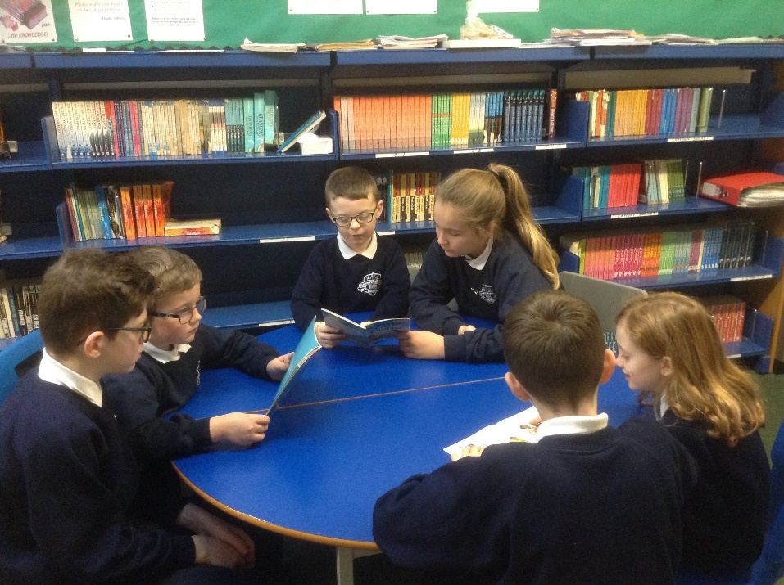
The nursery classes offer a curriculum that is balanced and broadly based and which promotes the spiritual, moral, cultural, intellectual and physical development of the pupils. This curriculum will seek to prepare the pupils for the opportunities and responsibilities their future may hold. It will also be the aim of the school to maximise the potential of each pupil, to develop self-confidence in the pupils and to promote a spirit of tolerance towards others. The six areas of the curriculum are covered by careful and imaginative planning by the nursery teachers. The combined expertise of all nursery staff ensure that your child/ren benefit from learning in a safe, stimulating and happy environment.

All parents will be issued with a curriculum overview at the start of each academic year. Additional information is available on the school website or can be requested from the principal.

The School Day

The school hours are as follows:

Nursery | 9.00 am | 1.20-1.30 pm
Primaries 1 to 2 | 8.55 am | 2.00 pm
Primary 3 | 8.55 am | 2.00pm Autumn/Spring Term
 | 8.55 am | 3.00 pm  Summer Term
Primaries 4 to 7 | 8.55 am | 3.00 pm

All children should come to the playground in the morning and line up in class lines when the bell rings at 8.55am. Children are supervised in the playground from 8.45am. When the bell rings they will be brought to their classes by their class teacher. On wet mornings children should come directly to the assembly hall through the doors at the rear of the school.

Meal Arrangements
Lunch/Dinner Times
Nursery | 12.00 to 12.45 pm
Primary 1 – Primary 3 | 12.00 to 12.45 pm
Primary 4 – Primary 7 | 12.45 to 1.30 pm

Dinner from the school canteen is at a cost determined by EA. Application forms for assistance with payment of school dinners are located at the school front door. If your child chooses to take lunches, you are asked to bear in mind our healthy eating policy and refrain from including fizzy drinks or sweets in children’s lunch boxes. Nursery and Foundation Stage children get a healthy snack every morning.

Uniform
It is the Board of Governors’ wish that all pupils should wear the school uniform which can be obtained at a reasonable price at a variety of local stores. The uniform gives the children a sense of identity with St. Moninna’s P.S., Cloughoge. If for any reason a child cannot wear the uniform the Principal should be notified.

Sweatshirts and polo shirts with crest are supplied by McEvoy’s, Monaghan Street, Daisy’s, Hill Street and Saints & Scholars, Mill Street as well as online from School Trends. Other items of uniform can be purchased in many high street stores. Forms for assistance with purchases of uniform are located at the school front door. All items of uniform should be clearly marked with your child’s name.
Nursery Uniform
Nursery Navy Sweat-shirt with Small Crest
Polo Shirt (selection of colours)
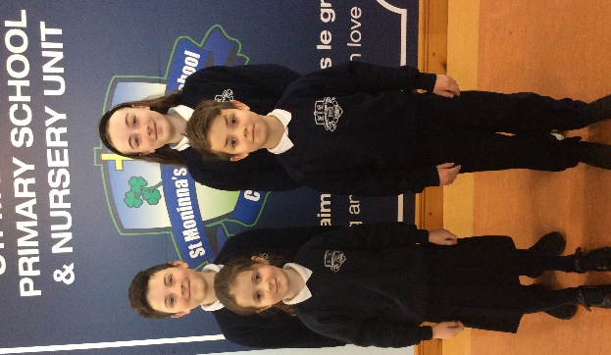
Navy Jogging Bottoms/Trousers (no logo on the bottoms)

Primary 1 to 2
Navy Sweat-shirt with Small Crest
White Polo Shirt
Navy Jogging Bottoms/Trousers (no logo on the bottoms)

Primary 3 to 7
Navy Sweat-shirt with Small Crest
White Polo Shirt
Navy Trousers
(Navy Pleated Skirt Optional for Girls)

What shoes should my child wear?
We would ask that all our children wear plain black or navy footwear. We would ask that pupils do not wear shoes outside of these two colours and that they do not wear shoes with brightly coloured laces/logos.

PE
On PE days pupils should wear navy tracksuit bottoms and trainers.

Summer (Optional)
Navy Check Dress/Plain Navy Shorts i.e. navy shorts with no logo visible

Home School Partnership
Parents can and should help the school by taking an interest in all aspects of their children’s work, by speaking well of the school and the teachers, and encouraging their children to be well behaved. Parents can also help by encouraging punctuality, the obeying of safety rules, ensuring that children wear the school uniform which should be kept neat and tidy and by collecting their children from school at the appointed time.
We ask parents to show interest in their child’s class work and ensure that homework is completed to a good standard. They should be aware of school rules and procedures and encourage their children to abide by them. Parents are expected to attend planned meetings with teachers and support school functions. They should provide the school with all the necessary relevant background information about their children, or any significant change in their medical needs or home circumstances, including telling the school promptly about any concerns.

Parental Request for Visit
Parents are very welcome to come to the school at any time to discuss their children’s progress. To avoid disruption of classroom work the following procedures should be followed:

Emergency - Parents/guardians contact the school secretary who will arrange a discussion with the Principal, or in her absence, the Vice-Principal.

Non-Emergency - Parents/guardians should contact the school secretary to arrange a meeting with the class teacher at a mutually convenient time.

Progress Report
Parents will be informed of their children’s progress by:

An annual meeting in which parents will have a chance to discuss with the child’s teacher their child’s progress and outcomes of assessments if appropriate.

Parents will receive an annual written report, generally in June, on their child’s progress.

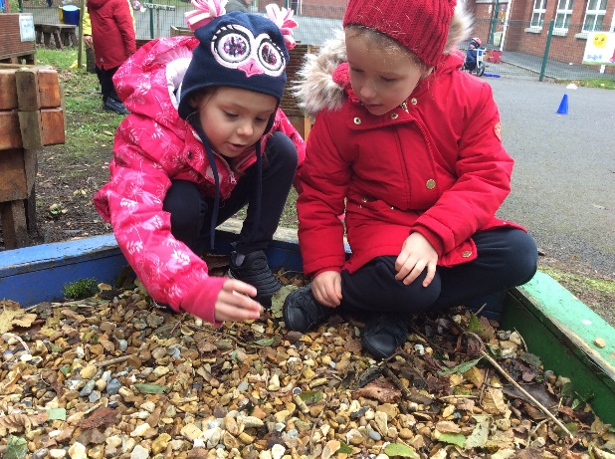
Pastoral Care
In line with the policy of maximising the potential of each pupil, the school recognises that it has a responsibility to do everything possible to care for each child’s physical and emotional well-being. The school will endeavour to provide a comfortable and safe environment for learning.
All teachers and staff in the school have a duty of pastoral care for pupils. The school would be grateful to receive any information about any difficult home circumstances which may be causing distress or anxiety. This information will be treated as confidential and relayed to others, with parents’ agreement, on a ‘need-to-know’ basis. Counselling support is made available to those pupils who may need it. The school will prioritise pupils who we feel would benefit from this service as and when it is available. A Pastoral Care leaflet incorporating Pastoral Care and Child Protection is issued at the start of each year. Detailed copies of our Pastoral Care and Child Protection Policies are available on request. In all cases it will be the school policy to act in the best interests of the child.

Positive Behaviour
It is part of St. Moninna’s Primary School’s policy to emphasise positive approaches to maintain and improve behaviour. Our school promotes positive behaviour and attitudes by recognising and rewarding them. Each week a child/ren from each class, Primary One to Primary Seven will be identified for the award of Merit Badge, which will be formally presented to them during school assembly by the class teacher. Children will wear the Merit Badge for one week and their names, including the reasons why they received the award, will be recorded in the School Merit Register. As a reward for achieving the merit badge the class teacher may present other privileges to the child/ren e.g. to be first in the line during the week. There is an Attendance award each month for the class with the highest or most improved attendance. We also recognise the year group best at lining up each week at our Friday assembly. In recognition of winning this, classes can take some extra play time the following week, when their teacher feels it pertinent to do so.
It is the school policy that behaviour should be based on respect for self, respect for other pupils and respect for adults. In those cases, where a child has not adhered to the school rules, there is a graded set of sanctions involving various members of staff in order of seniority. In any case, involving a serious breach of rules, parents/guardians will be involved and may be invited to come to school to discuss the matter. The school’s Positive Behaviour Policy outlines expectations, rules, rewards and sanctions.

Children with Additional and Special Educational Needs

Some of the children attending the school will have Special Educational Needs. These may arise from the child’s physical disability or his/her learning abilities. As it is the intention of the school to maximise the potential of each of the pupils, the school will endeavour, within its resources, to meet these needs.

All the teachers in St. Moninna’s P.S., Cloughoge have responsibility for children in their classes who have Special Educational Needs. It is our aim to ensure that the Special Educational Needs of children are identified as early as possible and that the procedures for meeting these needs are effective. We have adopted the Code of Practice and SENDO legislation which has enabled us to effectively meet the Special Educational Needs of the majority of children within the mainstream school with outside specialist help when necessary. As a result, children with Special Educational Needs are taught the Northern Ireland Curriculum by their class teachers within the normal classroom setting. Class teachers and assistants meet regularly with the co-ordinator (SENCO) to discuss ways of differentiating activities and use of alternative resources to overcome learning difficulties and draw up Individual Education Plans (IEPS).

We recognise the invaluable contribution that can be made by parents/guardians to assist their child’s progress and it is our policy to keep them informed and to invite them to work in partnership with the school at every stage.

Our SENCO co-ordinates SEN Provision and provides withdrawal sessions for particular pupils. It may be necessary to refer a child to Educational Psychology. The process of determining that a child has Special Educational Needs in accordance with the law is a lengthy one and involves close co-operation among the teachers/school, medical authorities, educational psychologists and the parents/guardians.

A copy of our Special Needs Policy is available in the school.

Holidays
The school will be closed for the months of July and August and for all statutory holidays. Parents will be issued with a holiday notification each year, as soon as they are agreed and ratified by EA. A number of exceptional closures are made available each year by D.E.N.I. for training purposes. Parents will be notified as soon as possible after these dates have been agreed. In the event of an emergency closure, every attempt will be made to notify parents to enable them to make alternative arrangements. Please ensure that your contact details are kept up to date with the office so that we can contact you in such incidences.

Parents are requested to arrange family holidays only during school closures.

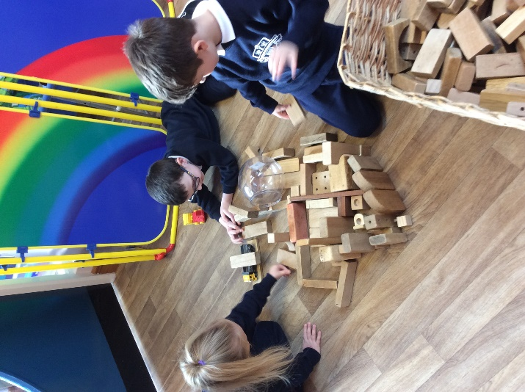
Pupil Attendance
Parents/guardians are responsible for ensuring that their children attend school and arrive on time for lessons. We work with parents when necessary to improve attendance and punctuality. If attendance falls below 85% the Educational Welfare Service are informed. Parents/guardians should inform the school by phone on the first day of absence and submit a note explaining the absence when the child returns to school. Our school’s annual average attendance is generally in excess of 95%.

Religious Education
St. Moninna’s P.S., Cloughoge is a Catholic Maintained School and the Religious Education Programme follows the requirements of the Diocesan Religious Education Committee. The ethos of the Catholic School permeates all aspects of school life and is delivered using the ‘Grow in Love’ series. Rev Fr Naughton is our school chaplain and regularly visits all classes. Prayer is a regular part of the school day. Each school year begins and ends with a school Mass to which parents are invited. Each class has Religious Assemblies throughout the year.
Children in Primary 4 will be prepared for First Confession and First Holy Communion and the pupils of Primary 7 will be prepared for the Sacrament of Confirmation.
Non Catholics may be admitted to the school by the Board of Governors and special arrangements can be made for such children if they wish to be withdrawn from RE lessons or ceremonies.

Equal Opportunities
We aim to promote an awareness of what we all have in common as children of a loving God.
We believe that every child should have equal access to the curriculum, play and social development. We expect every member of school to respect each other, whatever their race, gender, culture, religion, class, ability or disability. We encourage awareness and understanding of each other’s differences and will not accept verbal abuse of any kind, stereotyping, disrespect or physical violence. The school will consider the needs of both children with SEN and gifted children when allocating resources and every effort will be made to provide maximum access to the curriculum for all children.

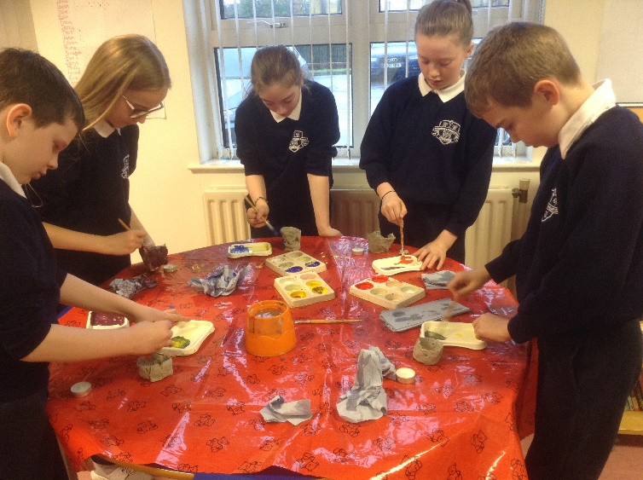

Homework
St. Moninna’s P.S., Cloughoge values homework as a means of reinforcing class work, to research information unavailable in school, to involve parents in their children’s studies and in the development of good work habits. Against this must be balanced each child’s need for recreation and the development of private interests and hobbies.

Parents are asked to sign that homework has been completed and are requested to send a note when a pupil has been unable to complete homework for any reason. It is school policy not to assign homework to children who are absent from school due to sickness.

Extended Schools & Extra-Curricular Activities
St. Moninna’s P.S. Cloughoge, offers a wide range of after school activities to cater to the interests and tastes of all of our children. Our activities schedule changes throughout the year with activities such as Gaelic Football, Gardening, Gymnastics, Soccer, French, Yoga and Dance being made available. In addition to this, other clubs run e.g. ICT, Irish, Art and Drama according to staff and expertise available. During the school day tutors from EA Music Service provide tuition on strings, brass, woodwind and drumming. The school participates in Newry Féis, Cumann na mBunscol blitzes, quizzes and many competitions both local and national. Our Extended Schools Programme includes the Morning Club, a 2-3pm Club and a 3-4pm Club. There is a £1 contribution requested per session. Additional Literacy and Numeracy support is provided through Extended Schools funding for identified pupils.

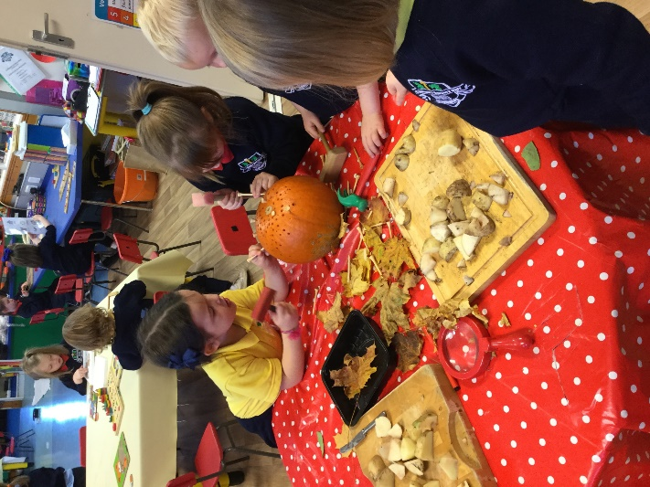

Charging and Remissions Policy
Education in St. Moninna’s P.S., Cloughoge is provided free of charge for all lessons and activities connected with the child’s entitlement under the Education Reform Order. The school will appeal to parents from time to time for voluntary contributions or donations but it is stressed that no child will be disadvantaged in any way if parents choose not to, or cannot afford to, make a contribution.

Charges for music tuition from the EA/private tutors will be passed on to parents. Arrangements for payment of afterschool clubs and services are made between parent and provider.

Drugs Education
The emphasis of our drugs education programme, as outlined in our Drugs Policy, is on the dangers involved in the misuse of tobacco, alcohol, medicine and other substances. This programme is delivered through Personal Development and Mutual Understanding, World Around Us and our Religious Education Programme.

Links with the Community
St. Moninna’s P.S., Cloughoge is proud of its standing in the community which it serves. The school works closely with the parish of Upper Killeavy and pupils from the school play an active role in the weekly liturgy in the Church. The school has many sporting links, the strongest of these being with St. Moninna’s GFC, Killeavy. The club assists the school in hosting blitzes and other events. The local business community supports the school in various activities throughout the year. The school also has close links with local primary schools, particularly the two other primary schools in our parish. We also liaise closely with St Paul’s H.S. and the local grammar schools as our pupils transition to post primary. Pupils also participate in charity events throughout the year and support local, national and international charities.

Road Safety
The Governors and staff of our school believe we have an important role to play in helping reduce the number of children killed or injured on our roads. We believe in educating for life in a very real sense and see Road Safety as a basic skill for survival. We promote this ideal through embedding road safety in our school and across the curriculum. Primary 7 pupils are also given the opportunity to participate in a Cycling Proficiency Course in school. We would appeal to parents to consider the safety of everyone when dropping off and collecting children from school. Speed and parking restrictions should be carefully observed.

Handling Complaints Procedure
The school values open communication and regular engagement between the school, home and other stakeholders. Therefore, we would encourage parents/guardians to bring concerns to us and we will aim to resolve them. In the first instance contact should be made with the class teacher. If the matter remains unresolved then an appointment can be made to meet with the Principal and/or a member of the Senior Leadership Team. If this fails to resolve the issue, then a copy of the school’s Handling Complaints Procedure should be sought (available on school website) and followed. The Procedure is now a simplified two stage process as detailed below:
Stage Two
Write to the Chairperson of Board of Governors
Stage One
Write to the Principal

This procedure applies for complaints/concerns in general, relating to all aspects of school life. The procedure is issued to all parents on an annual basis.

Mid-Academic Year Changes
If there are any changes in the above information due to unforeseen circumstances during this school year parents/guardians will be informed in writing of the nature of such a change.

If you have any queries, please do not hesitate to contact us. Likewise, if you are considering sending your child to our school and would like to visit please contact the school to arrange an appointment.

